1. Before understanding Spring Security Internals, take a look at the following two diagrams.  
   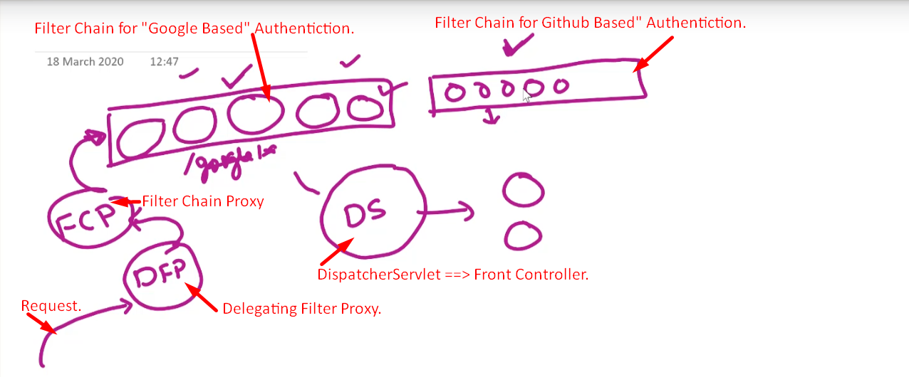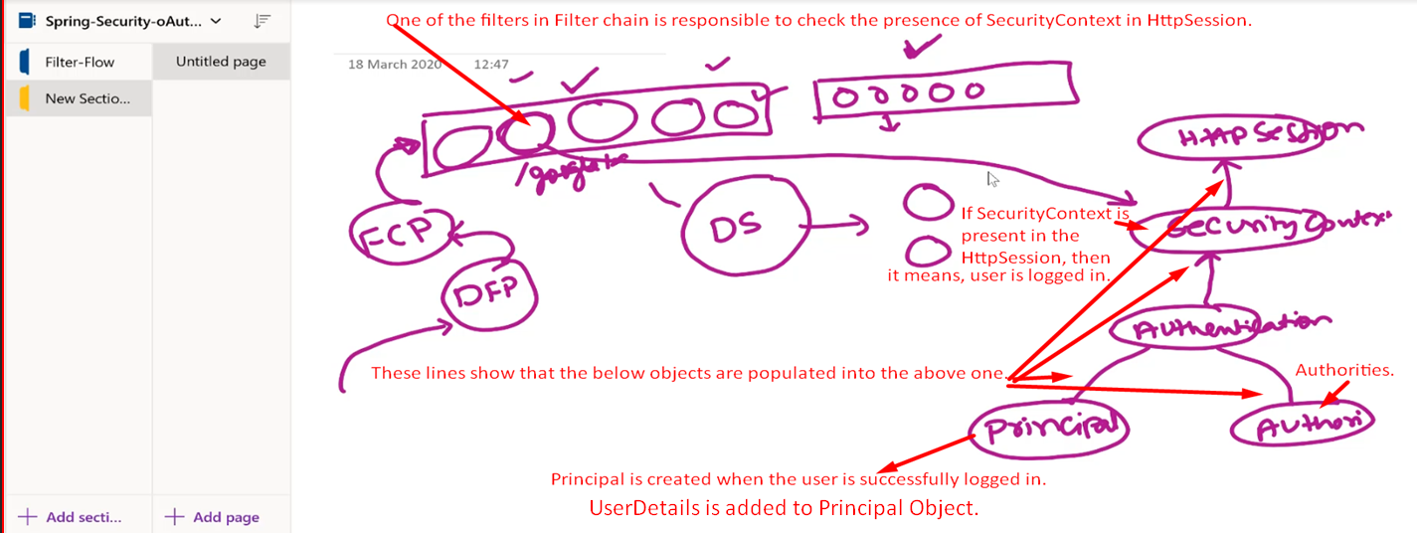
2. There are some scenarios when understanding the filters in the Filter Chain.
   1. User trying to hit an unsecured Resource prior to login.
   2. User trying to hit a secured Resource prior to login.
   3. User submitting login credentials.
   4. User trying to hit a secured Resource after logging in with required roles.
   5. User trying to hit a secured resource without required role.